Addendums:
The following are addendums to the previous incomplete essay on The Pillars of the Earth book by Ken Follett and 8 part Mini-Series adaptation of the aforementioned novel.

1: Themes & Concepts: Translating themes between book and mini-series

Hell
The theme of hell plays large across the novel and the tv series; as a primary motivator to either act towards or against a desired outcome – generally the avoidance of hell. Within the first episode Hell is mentioned just one (it appears again in later episodes) and Williams reaction to it, on screen, is visible anguish (see attached screenshot); and in the book this rings true:

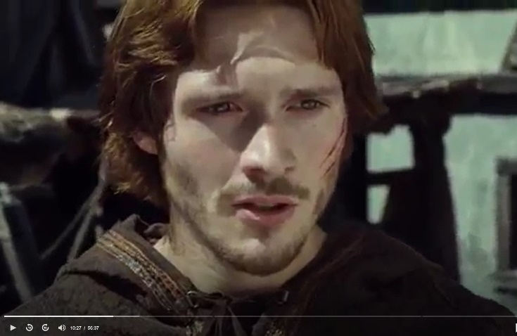
“The sneer froze on William’s face and he paled. Tom was surprised: what had frightened the boy? Not the mention of hanging, surely: it was not really likely that the lord would be hanged for the murder of a craftsman. Was he terrified of hell? They stared at one another for a few moments. Tom watched with amazement and relief as William’s set expression of anger and contempt melted away, to be replaced by a panicky anxiety.”

Hell is a consistent theme throughout the novel, and the mini-series – as it drives people, as a reminder of their destination after death; whilst William is the most visibly controlled via the consistent threat of eternal damnation; it motivates and drives many of the principle characters, including Bishop Waleran and Prior Philip:
“The bishop could torture Philip to make him reveal his source of information. Of course he had no right to, but then he had no right to plot against the king, either. Philip recalled the instruments of torture depicted in paintings of hell. Such paintings were inspired by what went on in the dungeons of barons and bishops. Philip did not feel he had the strength for a martyr’s death.”
It is this theme of hell that is perhaps the most easily translated one from book to mini-series; visually playing out in many ways throughout the series; as well as verbally – and often as a way of controlling the actions of other people – whether to deter them from, or threaten them towards, a course of action.

Pillars

“Through Philip’s eyes, we see that evil is the result of arbitrary authority, and that the guide through such barbarity is adherence to values that can be passed down from one leader to another. Leadership is a pillar, according to the biblical passage Samuel 2:8 from which Follett’s book derives its title: "He raiseth up the poor out of the dust, and lifteth up the beggar from the dunghill, to set them among princes, and to make them inherit the throne of glory: for the pillars of the earth are the lord’s, and he hath set the world upon them." Philip is among these pillars, a God-appointed leader of flocks.”

Highlighting the biblical verse of Samuel 2:8, from which the book is titled, SuperSummary highlights the pillars of authority theme which runs throughout the novel – with regards to the TV series this idea of who is and isn’t an authority is write large, as Philip and Waleran; Steven and Maud; Aliena and William; and many other characters jostle against one another for positions of power; the power play is written large in the mini-series as it is in the book – but whereas the book deals with the internal verses external struggle as individuals face the powerful and powerlessness; the mini-series focuses on the external – this is largely because the audio-visual medium finds it difficult to convey thoughts and emotions. One place we do constantly find the mini-series engaging this concept of power on the internal struggle is with the aforementioned theme of hell; as those who can forgive and pardon the sins of characters like William are the Churchmen; holding power and sway over the kings, lords and commoners a-like.

Justice
Attached to the theme of Hell and Power is the ever present desire for Justice on the part of Aliena and Richard – again something well played out in the television mini-series; and largely unspoken (appearing as the word ‘justice’ 26 times in the novel) – this is written more clearly when the eldest monk, Brother Thomas, speaks: “The king is not perfect. There is only one true judge, and that is God.” The issue largely appears in the novel as a question of who has the right to dispense justice – and largely it is seen as the rich and powerful; only characters such as Philip and Brother Thomas realise that justice is not truly dispensed by the rich and powerful, but by God; with Aliena realising in many respects that one must cease ones own justice by the horns. Again the theme of hell plays into this, as Characters such as William and Waleran fear the ultimate dispensation of God’s justice through hell.

Power & Corruption
With the recognition that hell is often a powerful motivator, but that the corrupt and powerful bend others to their will; the novel and tv-series highlight the power-struggle between Bishop Waleran and Philip as the primary evidence of this theme – with the powerful and corruption of Waleran, and the truth-and-justice warrior in Philip. However, that power corrupts is also displayed the form of Stephen; Maud; William – and to lesser extents Aliena; Richard; Lady Regan. Eventually against odds we see justice restored with the hanging of William in the book and miniseries; as well as Waleran falling to his death, in the mini-series (though the book has him return to life as a humbled monk). Throughout the book and mini-series the theme of justice is played out as a battle between Good verses Evil – as the those who deserve justice are denied by the rich and powerful; though good triumphs over evil by the end of both.

It is important to recognise that the themes of good-vs-evil; justice; are played out well from book to mini-series; with an almost nod to the book the mini-series delivers these key themes as a backbone to its storyline; but fails to adequately do justice to them, often through an inability to capture thoughts displayed into the book; at times making us believe that the series is really little more than a cliff note on the book, though when it does shine in comparison is the theme of hell and William Hamley’s utter dread in relation to hell.

Character Development
Although Character Development is not a theme; its associated themes within the book including Coming of Age, for Jack, William, Alfred, Aliena, Richard, Martha and even Jonathan, Tom Builder’s son and later Prior of Knightbridge.

Coming of Age
Whilst for the primary characters the book shows how they move from children to adulthood and to later adulthood – the mini-series, despite attempting to cover almost the same amount of time as the book; fails to deliver these theme convincingly – primarily as it fails to convey their aging effectively; but also its plot moves to fast to really capture the character development of the book; in many ways the life-like characters within the book become merely 2D animations within the mini-series; a pale imitation of their namesakes within the book.

Individuals vs Society
Whilst character development fails for the theme of Coming of Age for the mini-series; the themes of individuals challenging social conventions are loud and appropriate for the tv-series; this is never more so than in the sequal series World Without End, but Aliena’s life as a Wool Merchant is mirrored by Empress Maud’s rejection by the Church and many of the nations Lords, because she is a woman – and woman can’t rule the land:
“Stephen has the support of the Church and the backing of any who fear being ruled by a woman.”

Survival
The majority of Chapter 1 – 3 of the book are about Tom the Builder and his family trying to survive; to survive winter; starvation and poverty – this is alluded to in the mini-series – but never becomes convincing as the pace of the show doesn’t allow us to dwell. This is also true of the survival theme for Aliena and Richard – which occurs on-and-off from Chapter 3. This major theme of survival throughout the book isn’t translated well to screen – the time devoted to it just can’t do it justice.

War
Whilst the majority of the novel and the book take place during the period of English Civil War known as the Anarchy, against this backdrop we never delve too much into the war itself, with just a few dedicated moments; which are translated well to screen with less time focused on this ever-raging war directly; and more around its’ fallout – the wars we do see on-screen and in the book are primarily the fallout responses – Richard vs William; Jack vs Alfred etc. It should be highlighted here that although these personal wars appear in both mini-series and book; the Richard vs William war is not so real in the mini-series as his sister, Aliena’s war with William is in the book – suggesting some character development of Richard was needed to flesh out his personal vendetta with William. This is also true of the Alfred and Jack debacle – as Alfred is seen as more violent towards Jack; Martha; and Aliena in the book, than in the mini-series.

Thematic Conclusion
Although the mini-series does at one level or another capture some of the themes of the book, it fails to do justice to them, primarily a time constraint, but also technically, without additional voice overs and point-of-view approaches it fails to adequately capture the thoughts and feelings of many of the primary characters. The speed with which the series races through the storyline of the book, means that it is unable to add adequate character depth to really bring the characters to life, as the book does incredibly well. With its treatment of the themes of the book, the mini-series comes off as a cliff note on the book, rather than a terribly faithful adaptation. Where the series does shine is its translation of the theme of the fear of hell.

Technical Codes as medium restrictions
I have already alluded above to the issue of time which affected the mini-series treatment of character development, themes and pacing of the story; and previously (within the originally incomplete essay) to the medium of the mini-series as entertainment – whilst the novel certainly is, the ability to portray graphic child-rape (as an example) in book is easier than on screen, especially for a UK BBFC rating of 15.

Music
Whilst the obvious statement of books don’t have music, the argument that the novel would if real be accompanied by Gregorian chants and early medieval Church and folk music; the mini-series opts for anachronistic classical sounding synthetic music which is often dramatic and typical of the film and tv medium. Now, this is not an issue – in the sense that one expects this from the medium, but it is a restraint and change – in that if a documentary we perhaps might have seen more contemporary sounds used; instead the medium is aimed at modern audience, who have expectations of what type of music would accompany each moment of a tv series and film – in this case the mini-series plays to tropes – dramatic music, chase music, it has all of these broadly defined and stylised musical pieces; something one should not ignore when comparing with a largely accurate historical novel (albeit with its own artistic license in many parts).

Editing
As previously mentioned the pacing of this mini-series is fast, eight episodes of forty-five minutes each to capture 806 pages is a challenge – and this is partially done through some interesting editorial choices – the cut-scenes.
The example that springs to mind is Scene 6 of episode 1 – where both Maud and Agnes (Tom the Builder’s first wife) are both given birth – though Maud giving birth is not in the book; it allows the introduction of a key character (Henry II). Another example within the first episode is scene 7 where two sets of Characters: Percy, Regan, William & Waleran; verse Gloucester; Maud & Bartholomew are able to make plans, connecting the fates of each set of plotters together; and moving the story forward. These cut-scenes in the editing allow the story to move forward and connect dots that entirely separate scenes would not. Whilst filmed separately they are edited together to allow you to feel the connections and see the story weave its tapestry forward. This is in some respects a translation from the novel which uses scene changes within the chapters (eg chapter parts).

Other points
I have previously mentioned (in this addendum) and in the unfinished essay this addendum is part of, that the mini-series has altered many things to make them onto screen – the significance of changes can not be over-emphasises. Firstly I have mentioned twice the issue of child-rape and the reason for the change between book and mini-series; the others of pacing; character-development etc are due to length of the medium – as well as the major inability to translate thought to screen or script. It should also be highlighted that a true adaption of the book would probably be an 18 or above, and be far more graphic, violent and broken up; as well as incredibly longer – the audio-book is over 37 hours long; and even if a picture tells a thousand words, you’d need at least 400 pictures to tell this story (the novel is over 400,000 words); it would perhaps been better if the mini-series had been longer, perhaps just 8 more episodes would have made it a more faithful adaption, and perhaps more character narration would have added depth to each character.

Ken Follett, The Pillars of the Earth (New York, N.Y.: A signet book, 1999), 20.
Follett, 113.
“Pillars of the Earth Character Analysis | SuperSummary,” accessed February 17, 2021, https://www.supersummary.com/pillars-of-the-earth/major-character-analysis/.
Follett, The Pillars of the Earth, 441.
John Pielmeier, “The Pillars of the Earth: Episode 1 - Anarchy,” 2010. Lord Gloucester in Scene 7

