Advert:
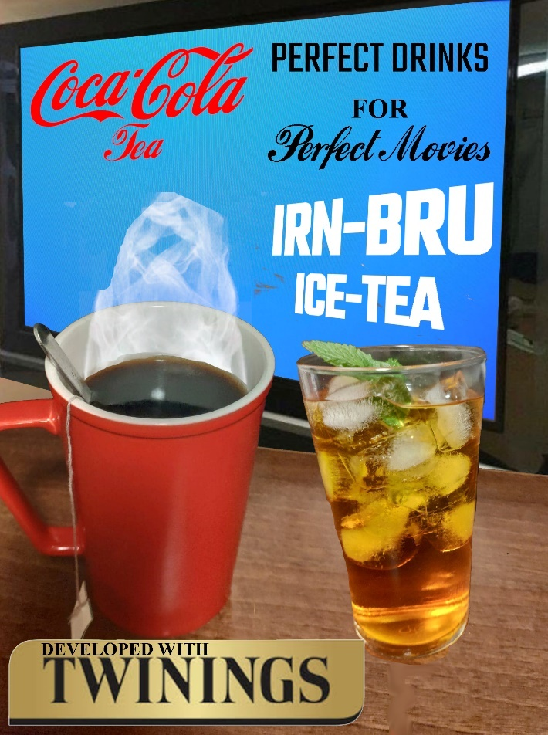
Original concept is a little rough, this was my attempt to put it together – realised (aside from my dodgy photography) where I went wrong.


One of the problems here was not shooting a whole scene first – so the two ‘teas’ and TV were shot separately – need to be shot together, up-close with a TV in the background, more like this kind of image:

The ice-tea glass probably worked the best, the coca-cola tea cup didn’t work so well – but would prefer to have had a glass tea cup to ‘show the tea’ (would have needed a real teabag then):

Advert needs to look more like the photo of the couple watching the movie (above) one with the IRN-BRU ice-tea, the other with the Coca-Cola hot tea – The TV Screen should not have the logo’s on it – that should be free floating text at the top & bottom.
The slogan needs to be more prominent, possibly in the centre of the screen between the TV and the cups – possible slogans:
Perfect drinks for perfect movies
Introducing cinematic cuppas…
Rename to IRN-BREW and maybe COCO-TEA instead of IRN-BRU and C
Like this: Coca_Tea and IRN-BREW
Screen should be a black and white out of copyright but well-known movie – maybe Charlie Chaplin(?) so as to help appeal to the audience of EMPIRE magazine.

