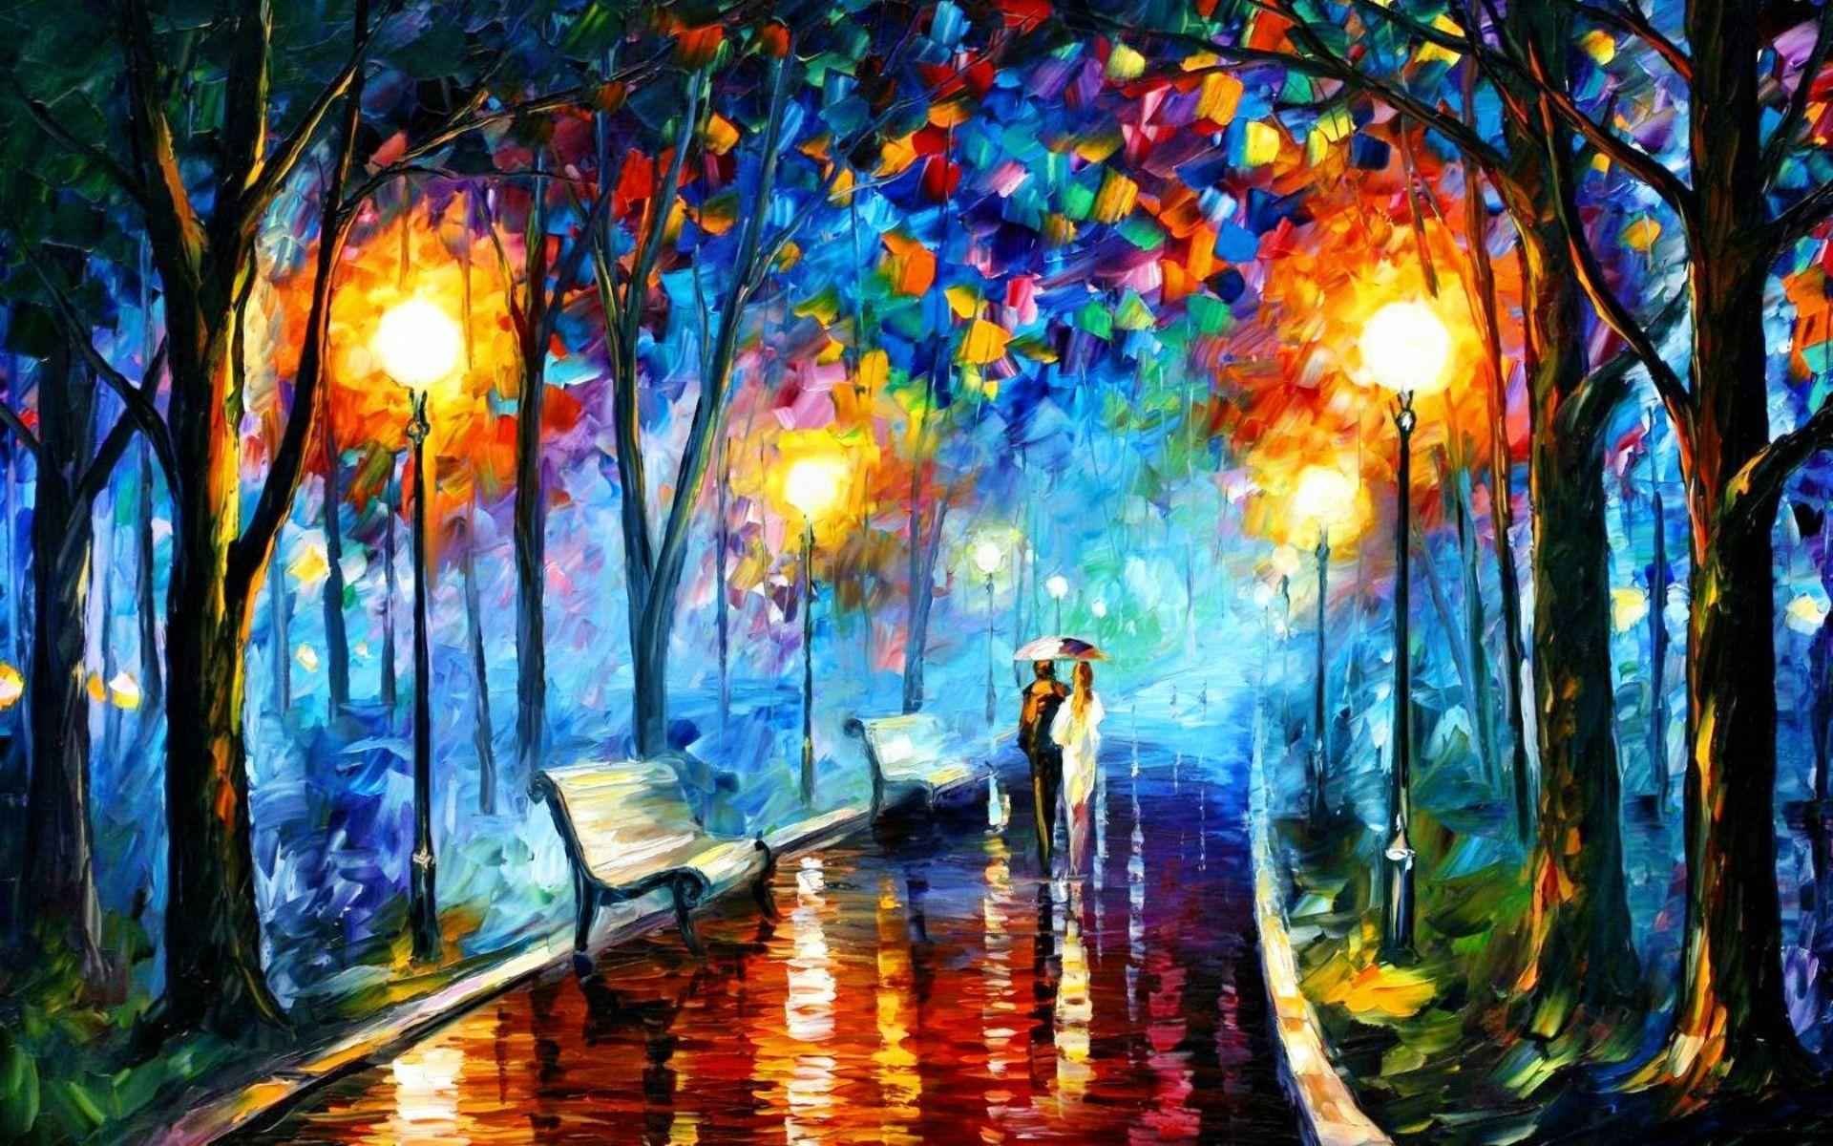
Picture THIS

DRAMA
COMEDY
MYSTERY
CRIME
SPY
ROMANTIC
ACTION

8 EPISODES 45 MINUTES LONG

SYNOPSIS
Each episode/chapter is a character portrait of 1 day – where the other characters ‘emerge’ through background interactions, and each is semi-POV, as the characters voice their thoughts and feelings off-camera and narrate the episode/chapter. Each episode will stylistic follow the genre of the artwork, and each episode is centres around a theft of a piece of artwork.

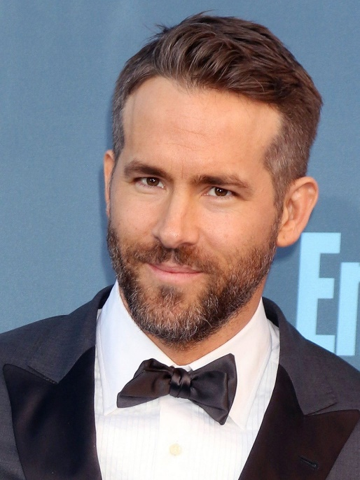
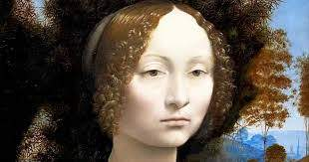
CHAPTER ONE: DA VINCI
MAIN CHARACTER – RALPH T JONES (RYAN RENYOLDS TYPE)
INVENTOR
FBI AGENT
NOW A MATURE ART HISTORY STUDENT AT YALE
This episode focus’ on the theft of DaVinci’s ‘Ginevra de' Benci’ from National Gallery of Art in Washington, D.C

Filming Style – Baz Lurhmen


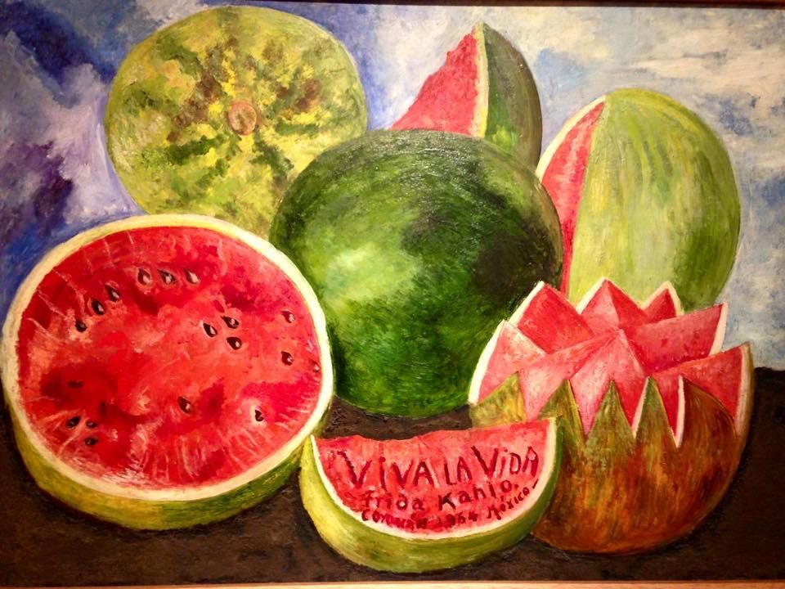
CHAPTER TWO: FRIDA KAHLO
PRIME CHARACTER – PROFESSOR MONICA HELM (CHRISTINA RICCI TYPE)
ART HISTORY LECTURER
SINGLE DIVORCED
ART FENCE
WORKING WITH THE MAFIA
Theft: Viva la Vida, Mexico

Filming style – Ang Lee
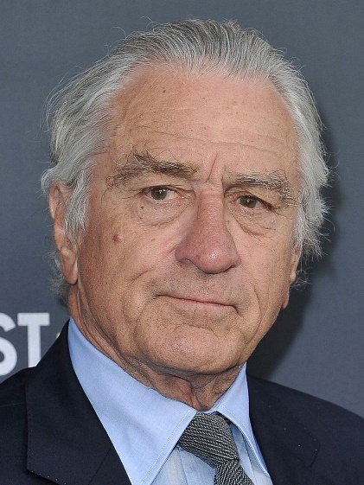
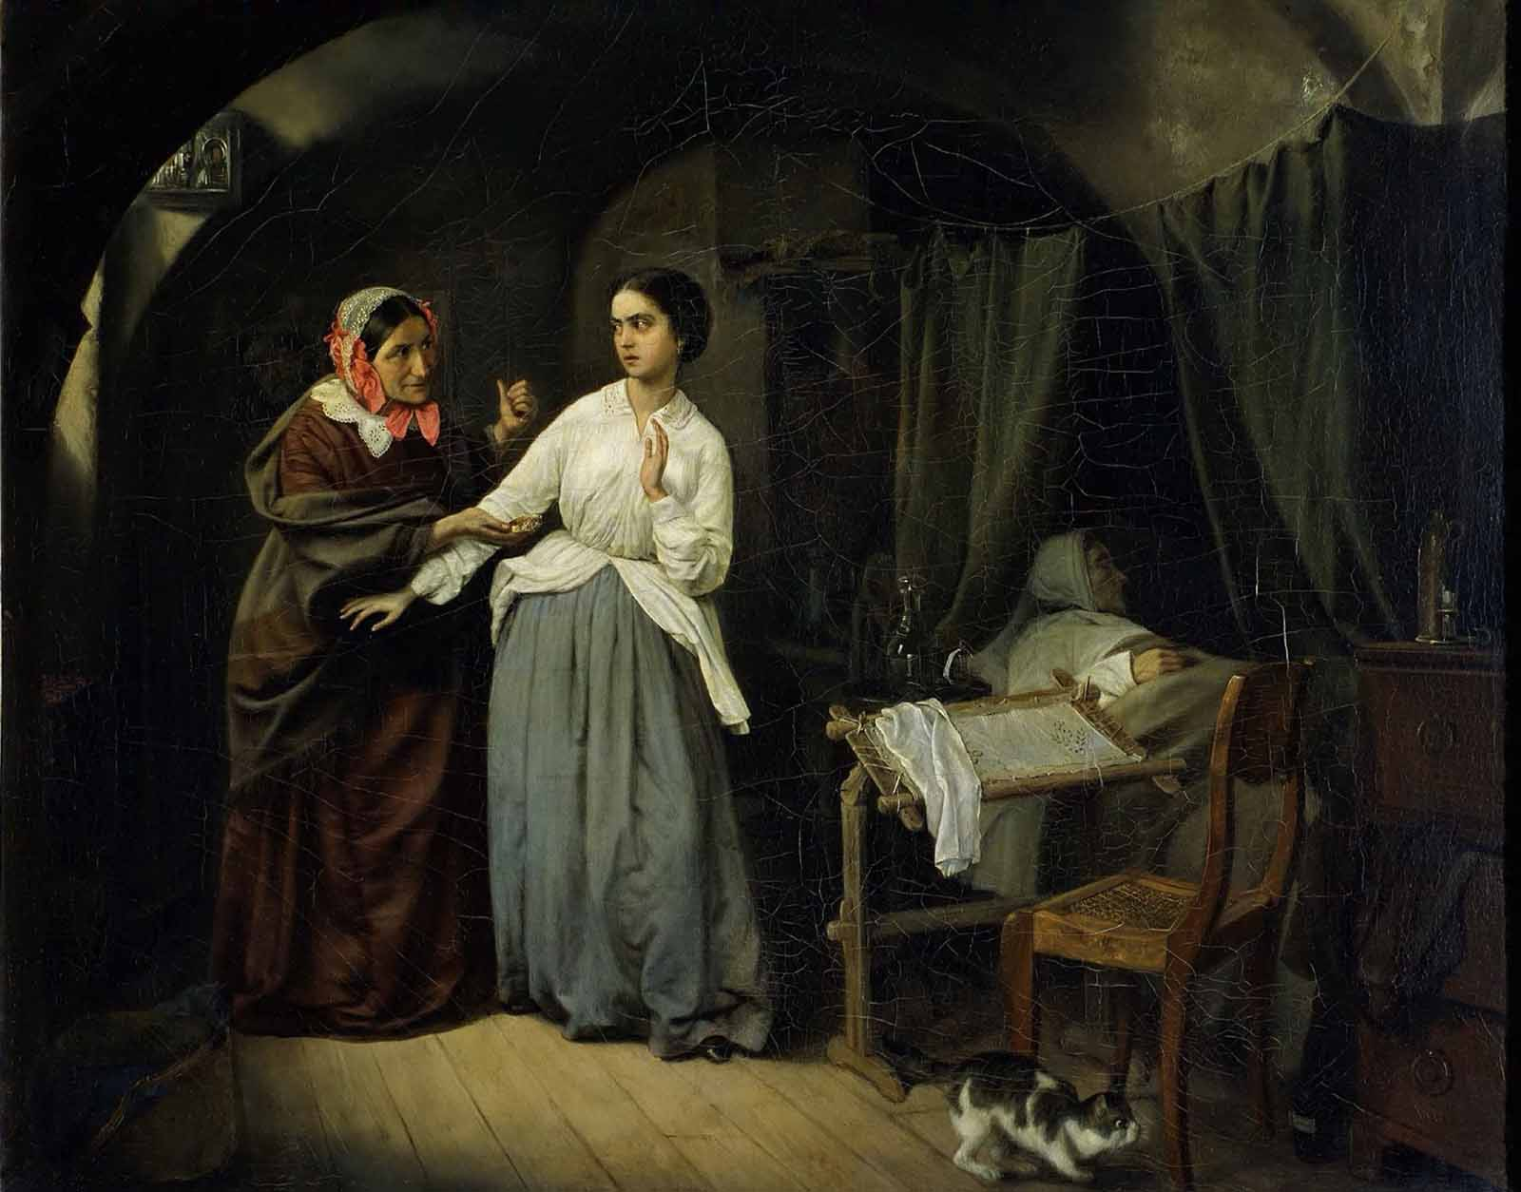
CHAPTER THREE: N. G. SCHILDER
SECONDARY CHARACTER – JOSEPH “FATHER” CAPRICE (ROBERT DENIRO TYPE)
MAFIA BOSS
THEFT: From the Tretyakov Gallery, Moscow

Filming style - Tarkovsky

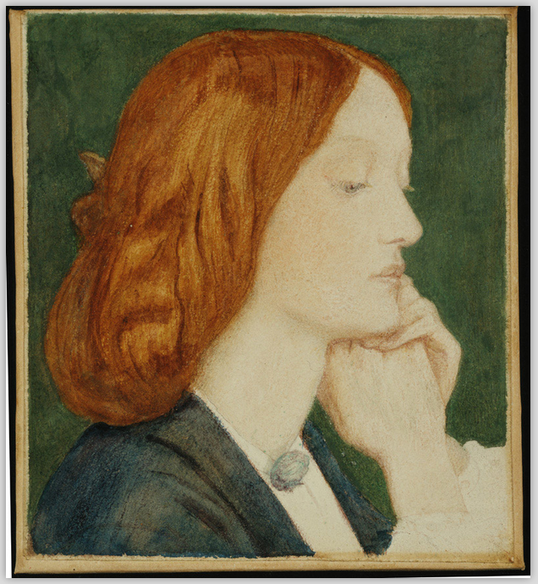
CHAPTER FOUR: DANTE GABRIEL ROSSETTI
MAIN/PRIME
RALPH & MONICA HAVE A PASSIONATE AFFAIR
RALPH DOES NOT KNOW MONICA IS THE ART FENCE
FOR THE MAFIA THAT HE IS LOOKING FOR
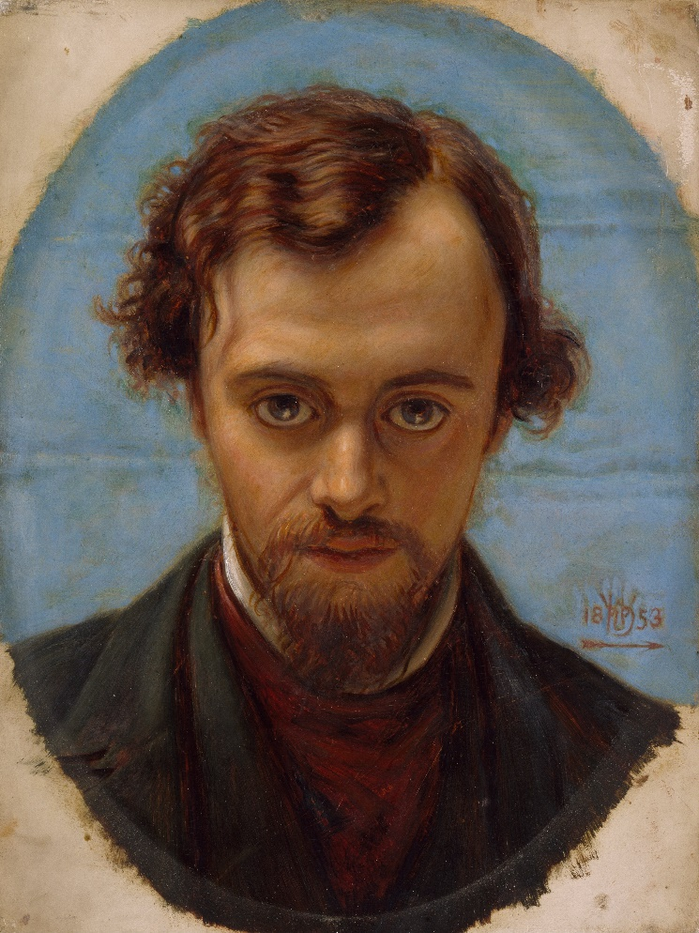
Theft: Elizabeth Siddle, Delaware Art Museum, Wilmington
Filming Style - Franco Zeffirelli
CHAPTER FIVE: ROY LICHTENSTEIN
SECONDARY CHARACTER – TONY PRESECCO (ADAM GILLEN TYPE)
COMIC RELIEF
HIS CHARACTER IS FROM BRITISH INTELLIGENCE AS THE TATE HAS LOST ` WHAMM! The art of Roy Lichtenstein
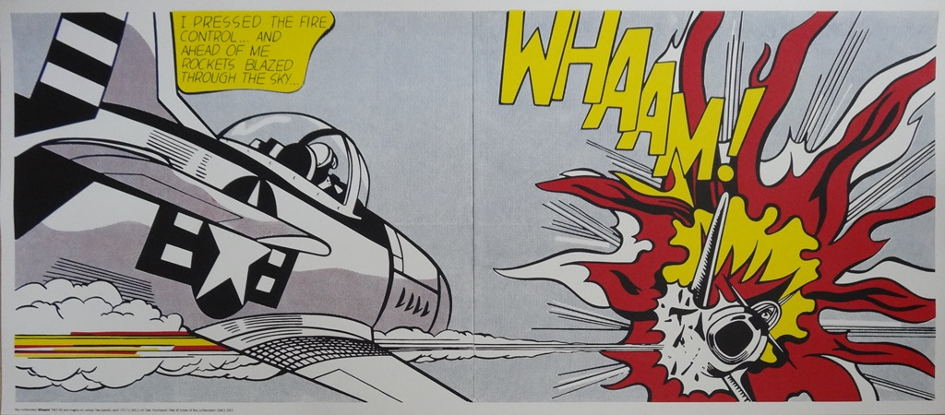
HAPHAZARD AND ACCIDENT PRONE COMEDIC CHARACTER AS HE FOLLOWS MONICA AS SHE FENCES THE ART FOR THE MAFIA
Filming style - Tarantino

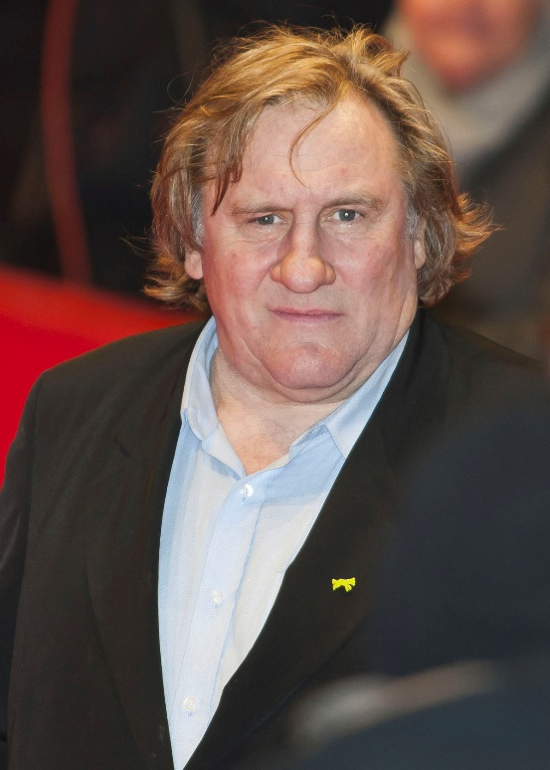
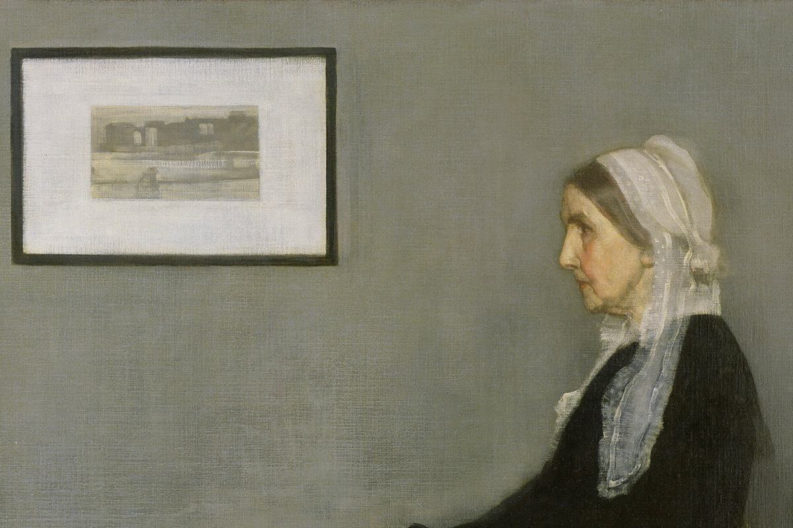CHAPTER SIX James Abbott McNeill Whistler
Secondary Character - Enzo Martin (GERARD DEPARDU)
French art crime specialist
Theft: Catches Monica as she escapes with
Whislter’s Mother from Musée d'Orsay

Filming style – Christopher Columbus

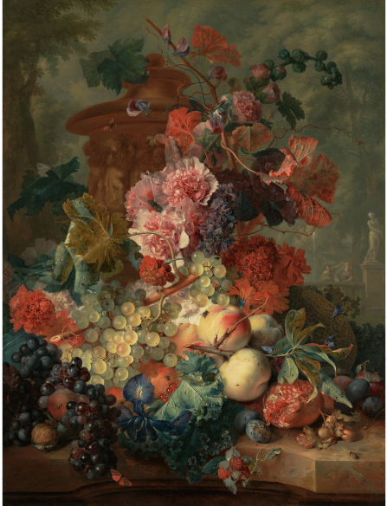
CHAPTER SEVEN: Jan van Huysum
Secondary Character: Christopher Hemmistein (Aidan Turner like character)
Reclusive ultra-effeminate art forger living in main
Forges art for Monica (Twist: She never sells the real ones)
Theft: Fruit Piece, Getty Museum

Filming Style - Lars von Trier

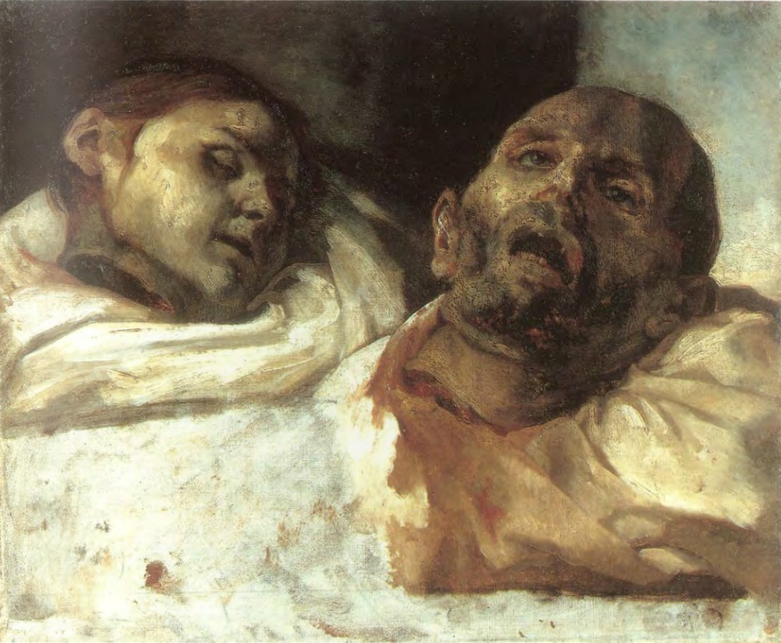

CHAPTER EIGHT: Theodore Géricault
Final Episode – All Characters meet, National Museum, Stockholm, Sweden
Third person view
As Monica goes to steal the painting ‘Heads Severed’ a shot is heard as Ralph, Enzo, Joseph take a shot – watched on by Tony and Christopher – they aim for Monica – but all miss her, but one shoots someone else… Joseph because he has found out she was fencing forgeries, Enzo and Ralph to stop the theft.
WE DON’T KNOW WHO WAS SHOT UNTIL A SEQUEL SEASON

Filming Style – Del Toro

Audience – Netflix distinguishes audience less by traditional demographics – but we would be aiming at those who enjoyed:
6 Underground (2019)
Murder Mystery (2019)
The Irishman (2019)
After Life (2019)
Stranger Things 3 (2019)

All are dark, comedic, dramas with some action and death being a consistent theme, and as Netflix states those with the widest appeal are cross-genre
Scripts to include references to great works of literature (not all so obviously as Shakespeare!)

Budget $7.5 million per episode (based on Netflix normal budget of $5 million – estimation for on-location filming

Themes – Art, Love, Lust, Death, Crime and Punishment

