SEMIOTICS:
  - A PATHWAY TO MEANING
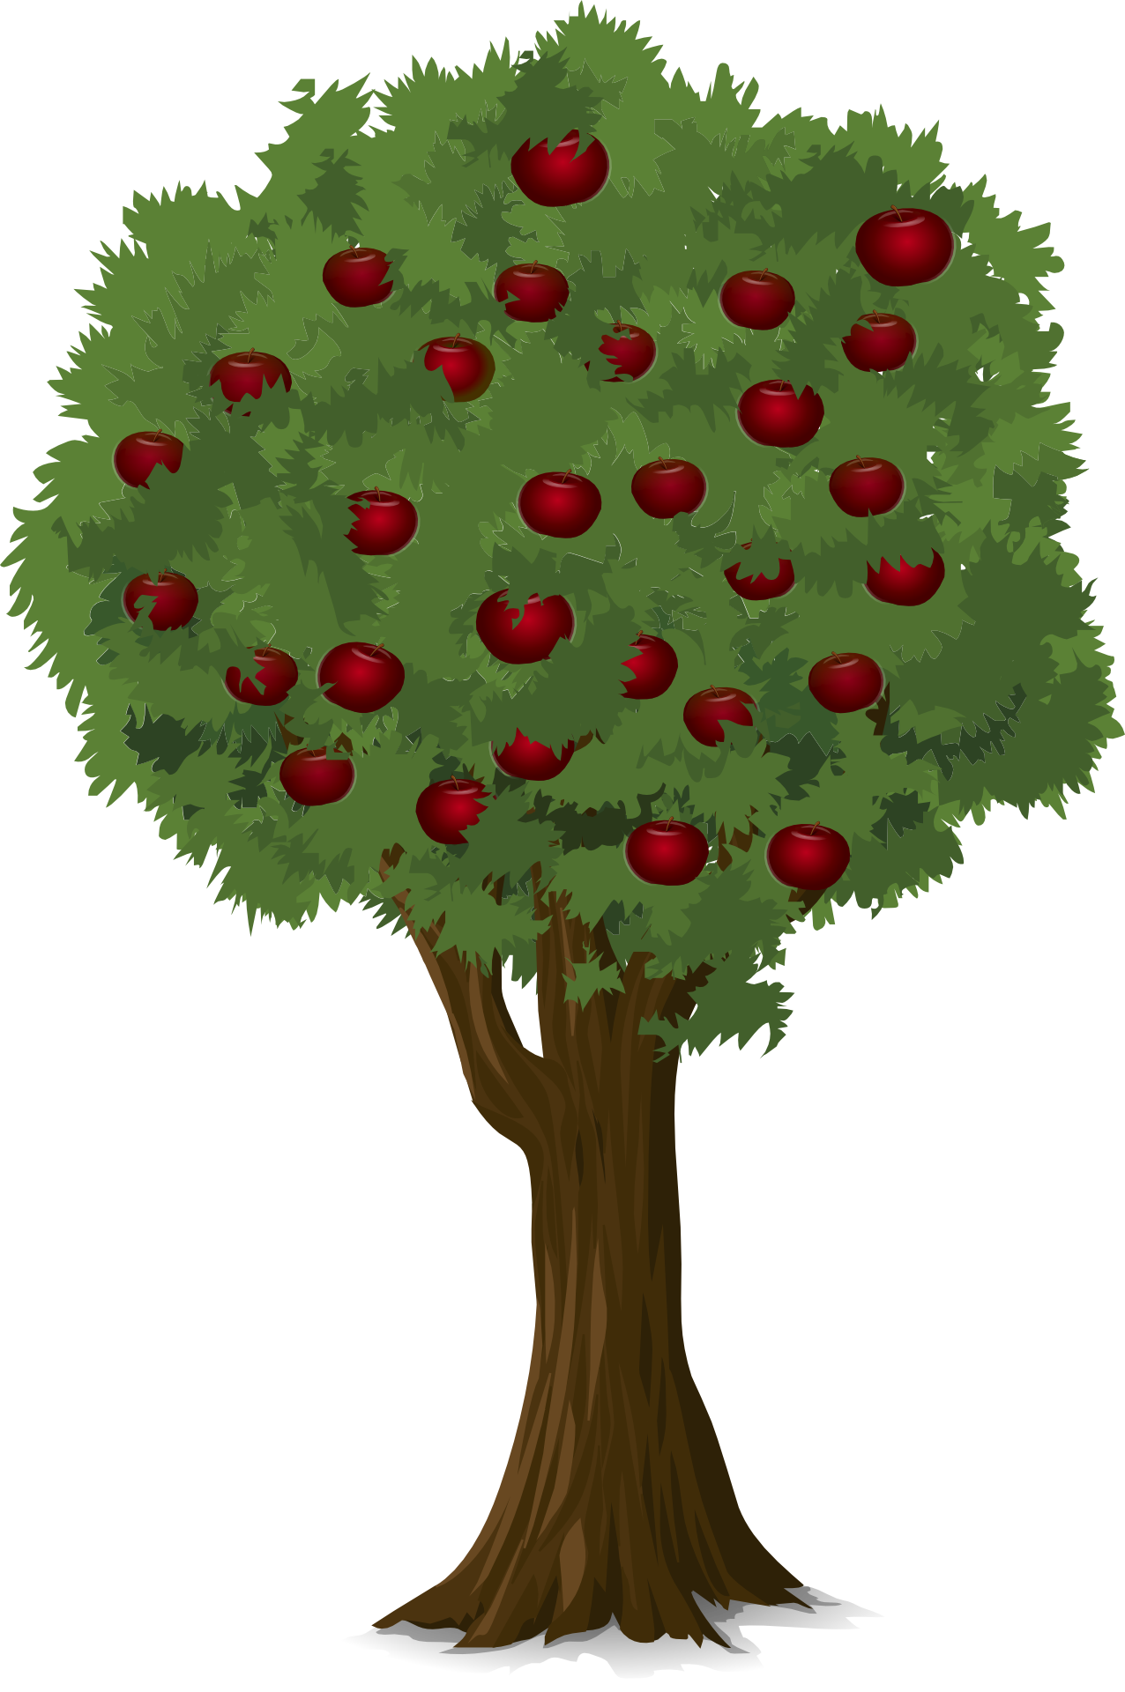
P E T CONROY

AVT SCRIPT

SCENE 1
[[00:00:00]]
Fade from Black to Long shot/full body shot of presenter “Jill Jones”
Presenter stands against a totally white background, stood on an animated brick road/path.
(5 seconds) [[00:00:05]]
PRESENTER:
Hello, I'm Jill Jones
Word “SEMIOTICS” appears in the white space above the road next to Jill
`and this is Semiotics:
The camera zooms to an upper body full shot, with the word “SEMIOTICS” and the secondary title “a Pathway to Meaning” underneath the word “SEMIOTICS” in the white space next to the Jill
A Pathway to Meaning, your guide to a journey of discovery.
Our journey starts with
Cut to shot of apple tree
A tree, an apple tree.
Zoom to include full body shot of Jill stood next to the apple tree
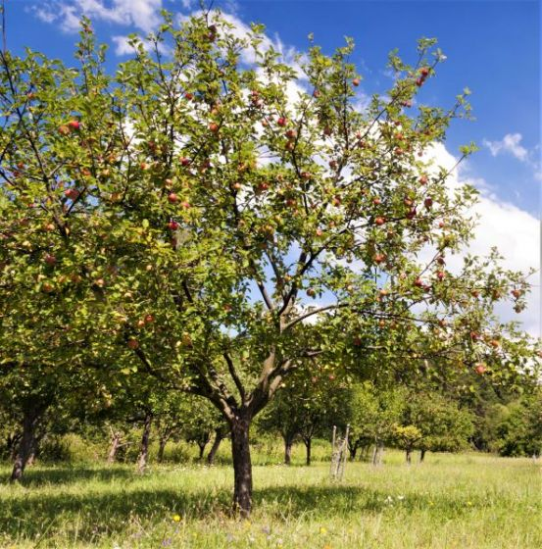
As I am stood next to this and can confirm it's reality, it is for me an actual apple tree, however, to you at home this is just a visual representation of an apple tree.

(25 seconds) [[00:00:30]]

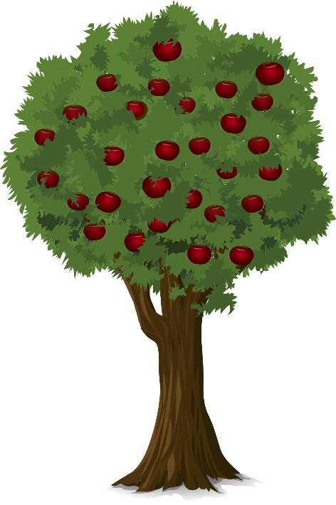
Let us make this discussion easier…
Presenter Clicks Fingers and is now stood next to an animated apple tree
This is now what is called an icon, it is not the object or concept of an apple tree, it is a representation of an apple tree. Therefor it is a sign – a signpost to an apple tree.
(15 seconds) [[00:00:45]]
Before we continue on our journey, lets break this down a little.
Cut to a white ‘split screen’ – one half [viewer left side] has ‘Signifier’ at the top and the other half [viewer right side] has ‘Signified’ at the top.
The signifier is a sign of an object, in this case the picture of an apple tree
Animated Apple Tree Appears underneath the word ‘Signifier’
The signified is the object, or the concept itself, so in this case the idea of a real apple tree, or a real apple tree itself
Actual photo/original apple tree appears under the word ‘Signified’
The signifier points to the signified
An arrow points between the two from animated tree to the ‘actual’ tree
The signifier is not the tree itself.
Another couple of examples to explain the concept.
(30 seconds) [[00:01:15]]
Cut to a camp-fire with smoke.
First take the saying ‘no smoke without fire’ – the smoke of a fire is a signifier that there is a fire. Again the smoke is not the fire, the fire is the signified object or concept represented by the smoke.
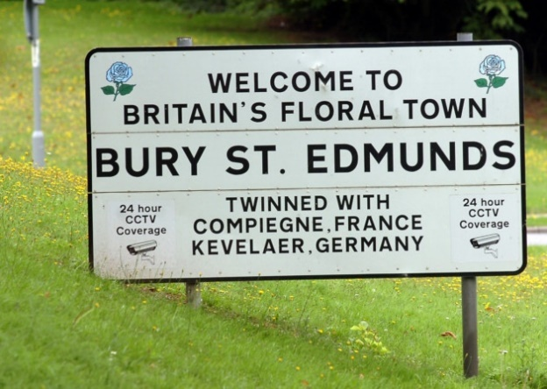
And a final real-life example
(18 seconds) [[00:01:33]]
Cut to a road sign saying ‘Welcome to Bury St Edmunds’
This road sign, signifies that you have arrived on your journey in Bury St Edmund’s, it points to your destination, is representative of, and is a signifier of, but…
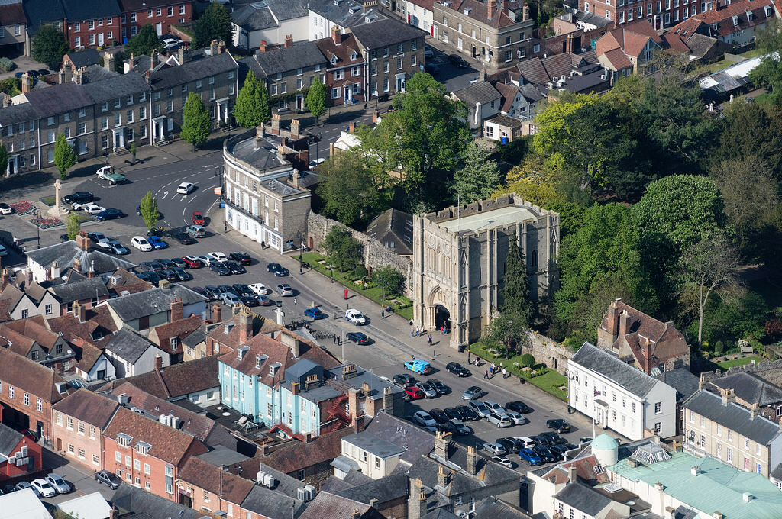
Cut to arial views of Bury St Edmunds
It is not Bury St Edmund’s itself, Suffolk’s Sleepy Market Town, is signified by this sign, just as it could be signified by its famous Abbey Gate, or even its Cathedral and a whole manner of things – but in this case the sign here is a signifier of the home of England’s original patron saint, and not the place itself.
(31 seconds) [[00:02:04]]

Cut back to the apple apple tree with Jill stood next to it
Returning now to our apple tree, we can continue to explain more about signs. I said before that the apple tree is an icon, this is because it is a direct representation of the object – a real apple tree, however
Zoom into apple tree, to an apple missing a bite
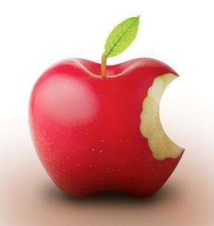
If we zoom into a single apple on this tree – you’ll notice it is missing a bite. As this is a ‘real’ apple or at least the direct representation of a real apple missing a bite, then it is an icon of an apple missing a bite.
However, if we dig for deeper meaning, it is also an index and a symbol. Let’s unpack this.
(35 seconds) [[00:02:39]]
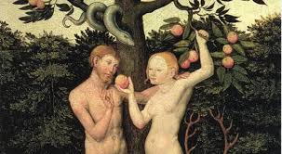
Cut to ‘Adam and Eve’ scene in the ‘garden of eden’ eating from the tree

To many people this apple is an index of the Adam and Eve story in the Abrahamic religions. Which tells how Adam and Eve ate from the tree of the knowledge of Good and Evil – although the original text does not connote an apple, it is the commonly associated fruit with the story. To those of faith, this is an index of that story – it is an index, because it is a signifier not of the apple itself but of the story – a story about a piece of fruit with a missing bite… there is a logical connection between an index and it’s signified object or concept.
(35 second) [[00:03:14]]
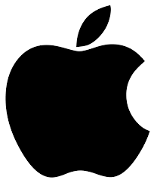
Cut back to apple missing bite – the apple will slowly change to become the Apple Inc logo.
…it is an index because it’s linked through meaning and not through direct representation.
However, to the non-religious and a vast myriad of people, this is not its primary meaning, and for that we have to turn to the final type of sign, as designated by Charles Sanders Pierce – Symbols.
A Symbol is a signifier of a concept, idea or object not by direct representation, or by indirect reference, but simply as the result of social and cultural identification. So in this case the apple, missing a bite, with that single leaf pointing to the right – is a symbol of the designers of the iPhone - Apple Inc. and in many senses the products they make. Symbol, therefore, is a signifier of an object or concept by social construction and not because it has any tangible or definable link. Just like the Apple Inc logo, has not logical pathway to being a computer, a company or a mobile phone, the only reason it is identified as these is by social construction.
(60 seconds) [[00:04:14]]
Return to full-shot of the animated tree and Jill stood next to it on the animated brick pathway
The story of the tree and the apple are at the start of our long journey to discover meaning, let us continue.
Jill walks along the brick pathway off screen
(11 seconds) [[00:04:25]]
the screen then pans to where Jill is stood >> SCENE TWO
(5 seconds) [[00:04:30]]

END OF SCENE ONE

